Drawn Layout

Here we have the basic structure of the website used and iterated throughout the pages.
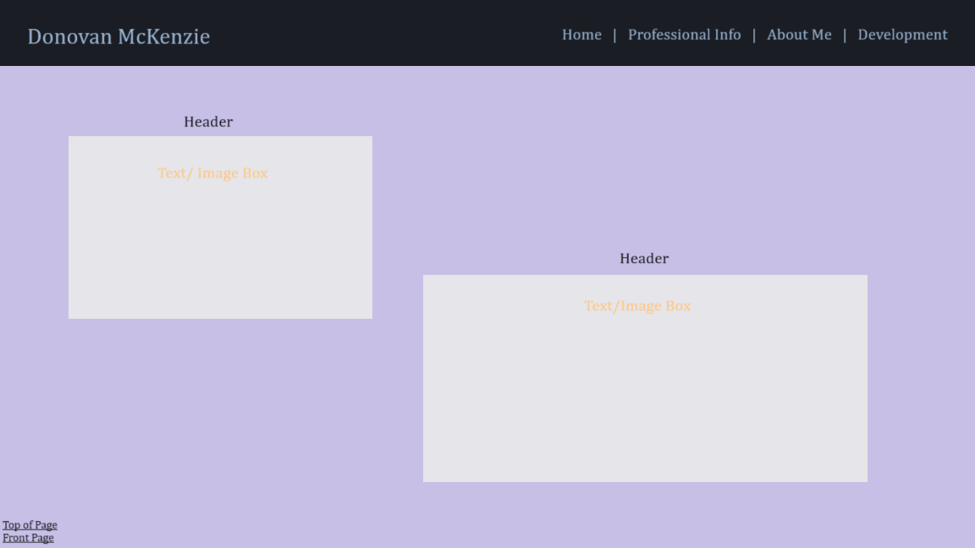

Web Pages

Homepage: Contains the introduction to the website with basic info

Professional Info: Contains my CV, vision statement, mission statement as well as soft skills and job requirements

About me: contains personal information, anecdotes and other information

Development: displaying the skills acquired in pursuing my degree as well as an analysis of “Twelve Pillars

Contact Form: contains contact information to reach me that wasnt already included on other pages, as well as best times to reach me.

